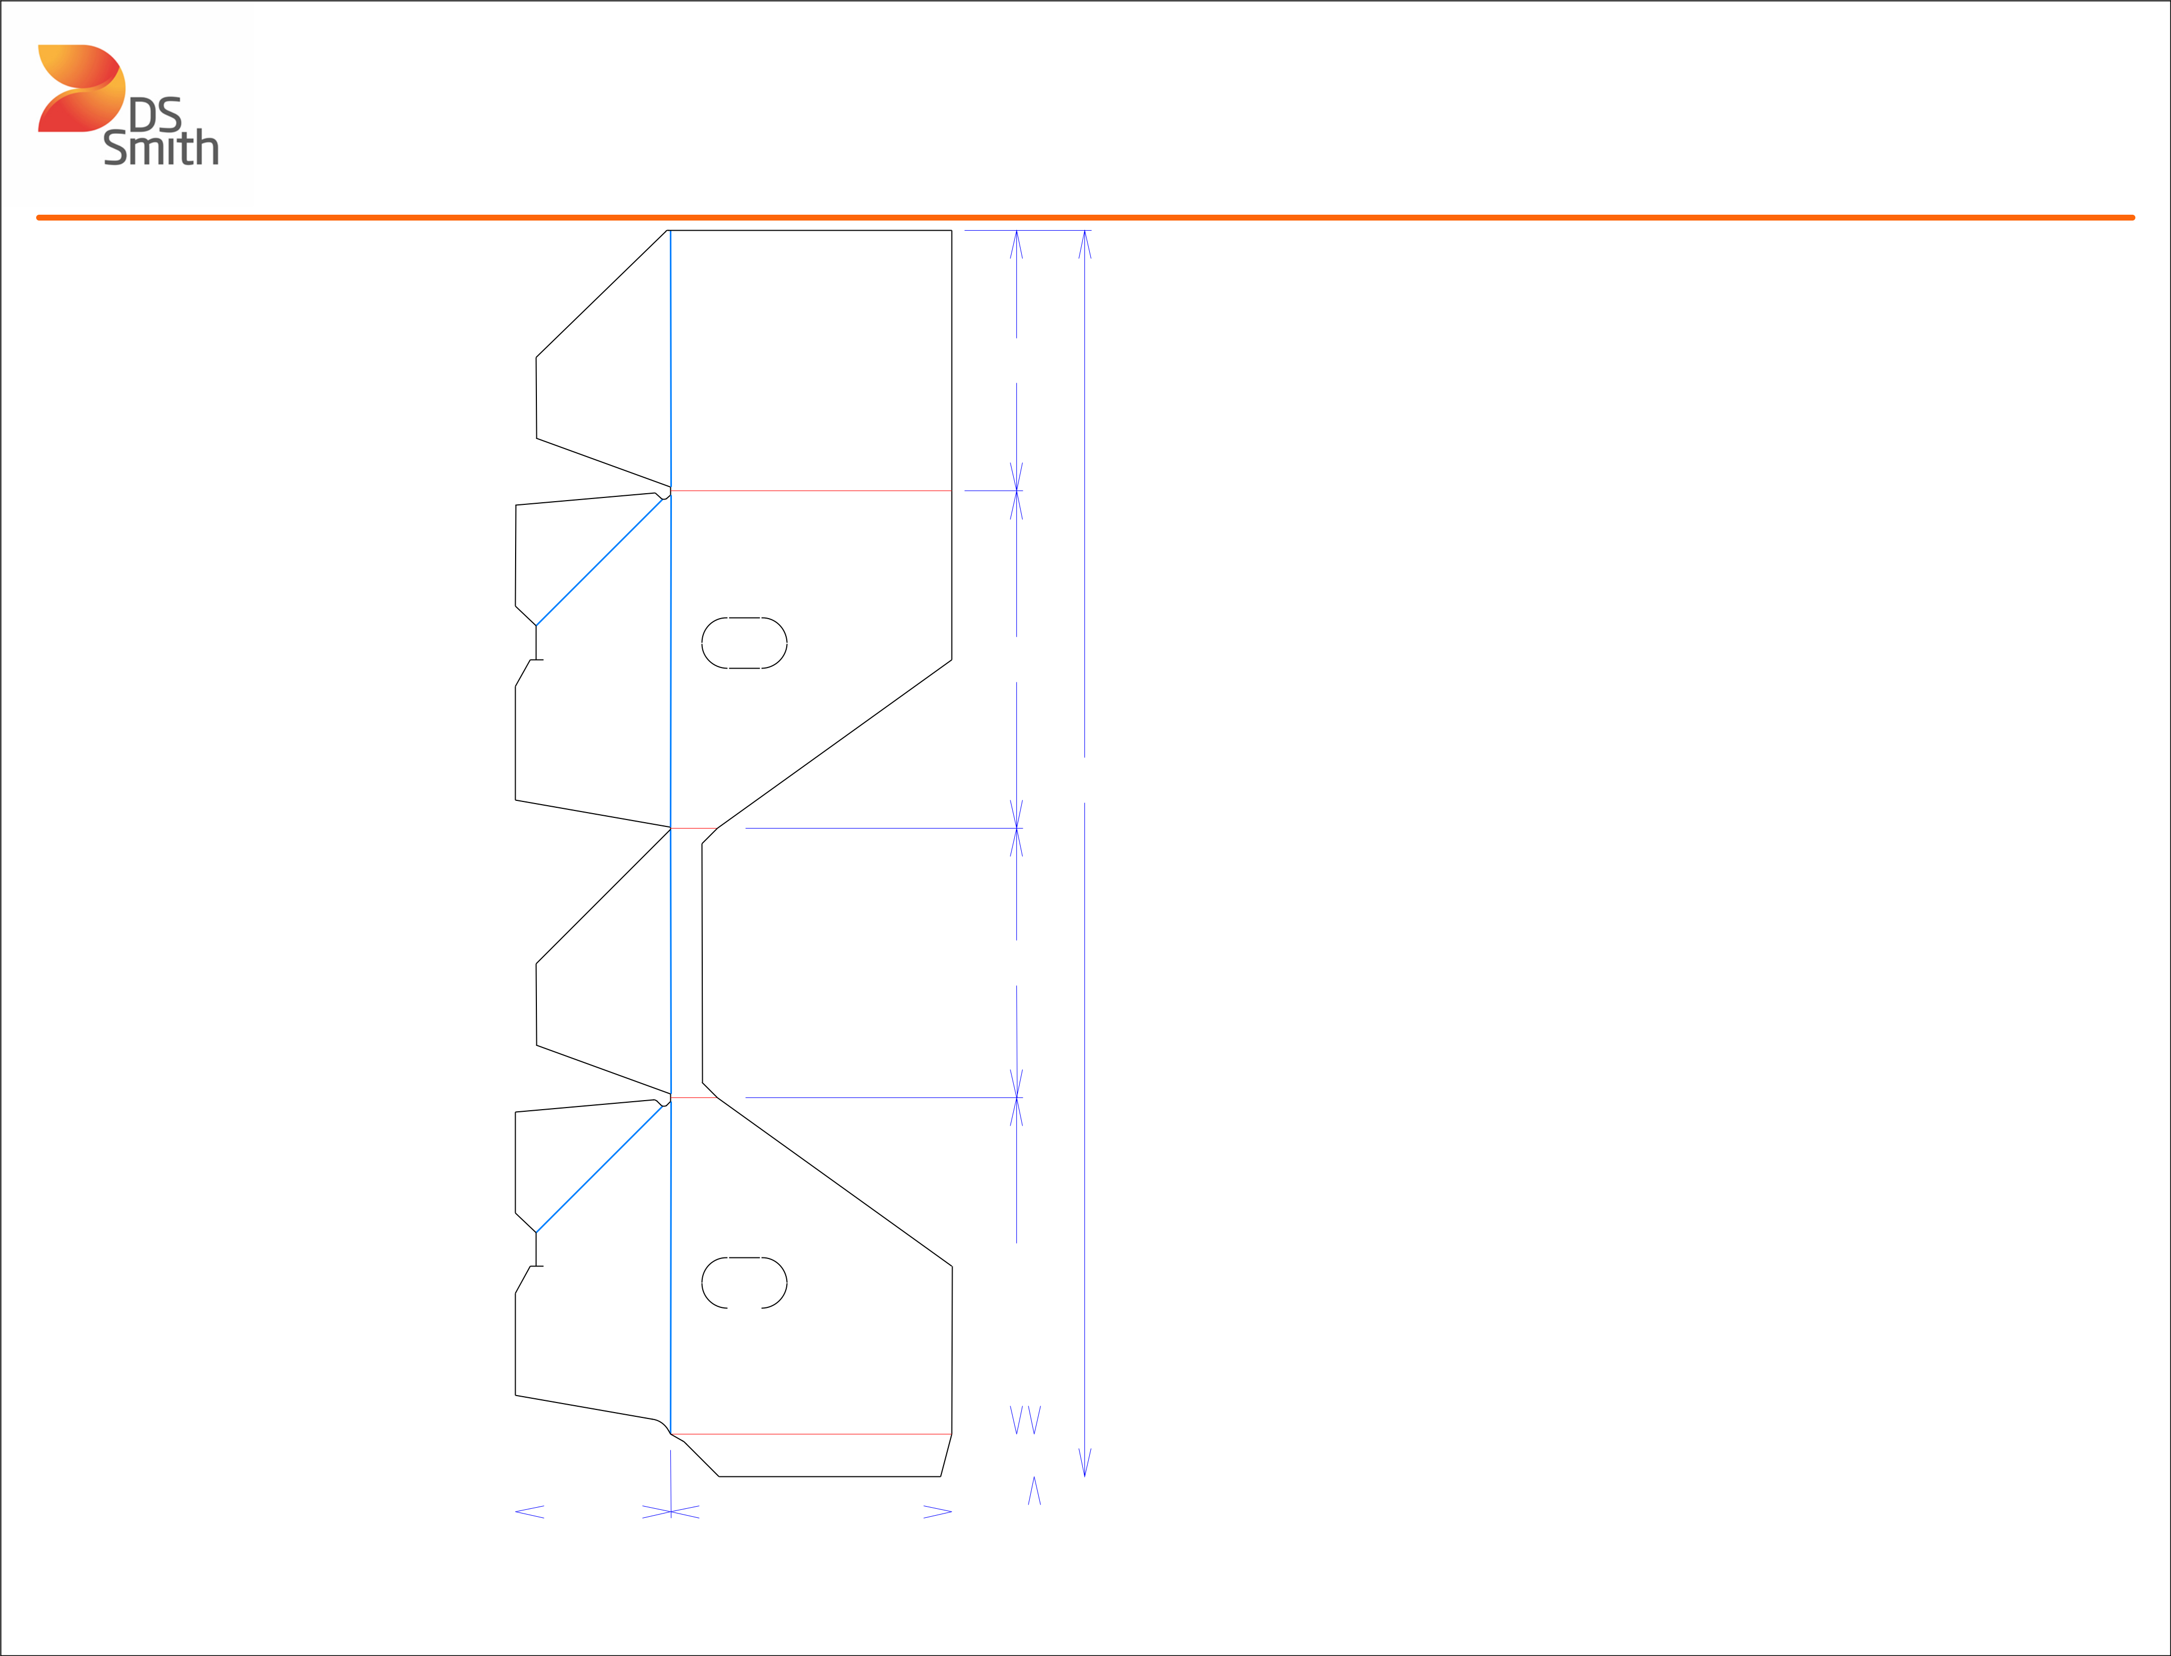

813*/*32

107*/*8

403*/*16

811*/*16

 1

11*/*2

1027*/*32

|  |  |  |  |  |  |  |  |  |  |  |  |  |  |  |  |  |  |  |  |  |  |  |  |  |  |
| --- | --- | --- | --- | --- | --- | --- | --- | --- | --- | --- | --- | --- | --- | --- | --- | --- | --- | --- | --- | --- | --- | --- | --- | --- | --- |
|  |  |  |  |  |  |  |  |  |  |  |  |  |  |  |  |  |  |  |  |  |  |  |  |  |  |
|  |  |  |  |  |  |  |  |  |  |  |  |  |  |  |  |  |  |  |  |  |  |  |  |  |  |
|  |  |  |  |  |  |  |  |  |  |  |  |  |  |  |  |  |  |  |  |  |  |  |  |  |  |
|  |  |  | 5 |  |  |  | 1 | |  |  |  | 13*/*8 | | | |  |  |  |  |  |  |  |  |  |  |
|  |  |  |  |  |  |  |  |  |  |  |  |  |  |  |  |  |  |
|  |  |  |  |  |  |  |  |  |  |  |  |  |  |  |  |  |  |  |  |  |  |  |
|  |  |  |  |  |  | 9 |  | 16 |  |  |  |  |  |  |  |  |  |  |  |  |  |  |  |  |
|  |  |  |  |  |  |  |  | / | |  |  |  |  |  |  |  |  |  |  |  |  |  |  |  |  |
|  |  | 141*/*16 | | | | | |  |  |  |  |  |  |  |  |  | Tear Tape | | | | | | | Perforation |  |
|  |  |  |  |  |  | Half Knife Cut | | | | |  |
|  |  |  |  |  |  |  |
| Cut | Crease | Crease with Matrix | | | | | Cut Crease | | | | |  |
|  |  |  |  |  |  |  |  |  |  |  |  |  |  |  |  |  |  |  |  |  |  |  |  |  |  |



Structural Design

(Inside View)

**Vertical corrugation**

Design#:

**200141-01**

Customer:

**DeMet's Candy**

Description:

**TTLS 8x6.4oz DCA SUB Holiday DRC - Tray**

**SINGLE-OUT DRAWING**

Qty/Unit:

Style: **PJDC**

Board: **32EW**

Combination: **36MW - 23M - 35HP**

I.D. : **10+13/16 x 8+5/8 x 9**

**O.D.: 1015/16 x 83/4 x 91/8**

Area of Blank - Waste : **2.76 sq. ft.**

Waste on Blank : **29.68%**

Finished Piece Weight: **0.28 lbs./128.28g**

Over-all Blank: **40+3/16 x 14+1/16**

**D/C from INSIDE**

**Matrix ALL Scores**

**X= Crush Areas Required**

Notes:

Revision Info: **[0] 02/24/2020**

Designer: **Amy Kirchhoff**

Designright and Copyright of DS Smith Corrugated Packaging Ltd. This technical Specification is subject to Manufacturing tolerances. Drawing dimensions shown are crease to crease. Date printed: 02/25/2020